m

Identifying controllers and drivers for vSAN supported esxi version

Identify if your card has been found sas disks and loaded by the host

esxcfg-scsidevs -a

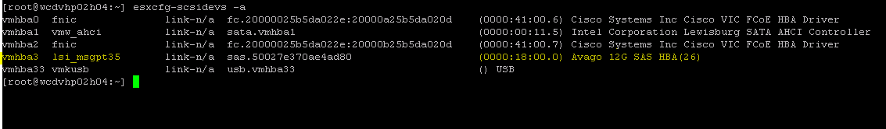

Controller has been loaded to adapter vmhba3 and it’s using the lsi_msgpt35driver.

Check which driver’s version this module is using

[root@wcdvhp02h04:~] vmkload_mod -s lsi_msgpt35

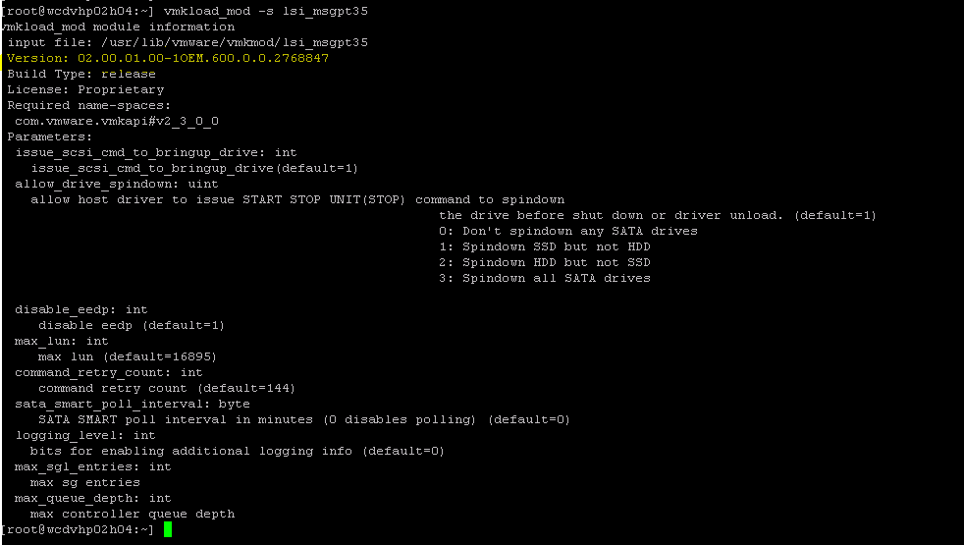

It is running version 02.00.01.00-10EM .

 Let’s list the device’s values of vmhba3

[root@wcdvhp02h04:~] vmkchdev -l | grep -i hba

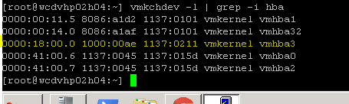

VID - Vendor ID: 1000

DID - Device ID: 00ae

SVID - SubVendor ID: 1137

SSID – SubDevice ID: 0211

Now let’s find exactly what this controller from vmware HCL. at this step we will just identify the correct controller model)

Switch the filter to IO Devices, then use the fields on the right to filter out with the details we just grab from the previous step.(VID,DID,SVID,SSID)

Once you update the results you will get your controller model.

<https://www.vmware.com/resources/compatibility/search.php?deviceCategory=io&details=1&releases=338&VID=1000&DID=00ae&SVID=1137&SSID=0211&page=1&display_interval=10&sortColumn=Partner&sortOrder=Asc>

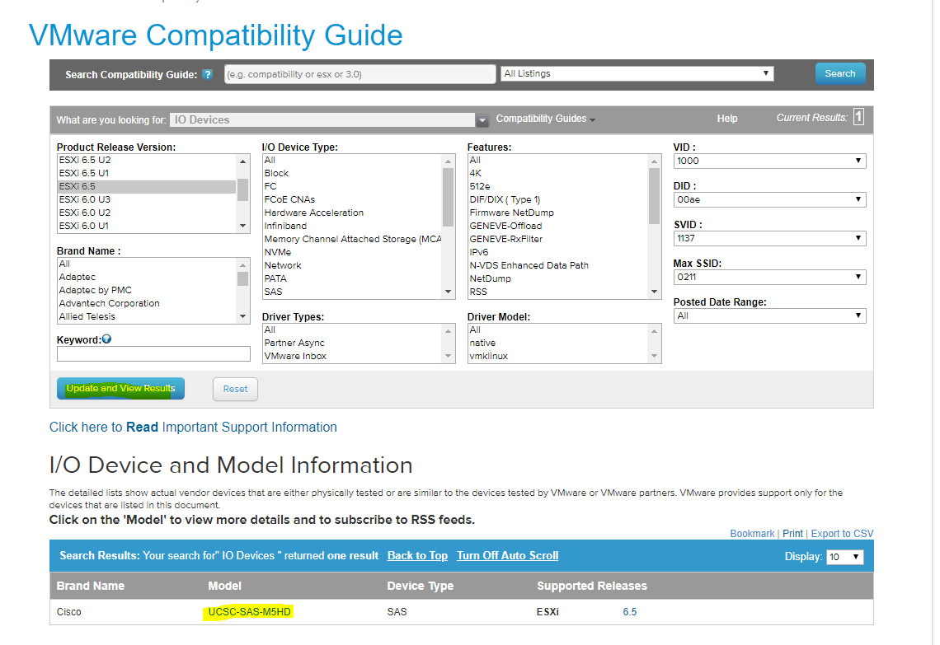

Your environment is running with 01.00.01.00 but latest is 07.00.02.00.

Before you go to latest you have to check cisco hardware device driver compatability also.

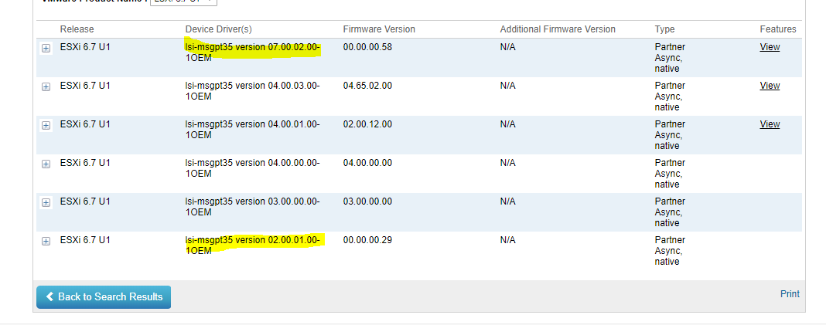

Controller model is UCSC-SAS-M5HD

(Remember it’s the general purpose information, and the idea is just to identify the controller based on the codes we got directly from the hardware itself.)

Now check your controller model will support VSAN with your esxi build version

<https://www.vmware.com/resources/compatibility/search.php?deviceCategory=vsan>

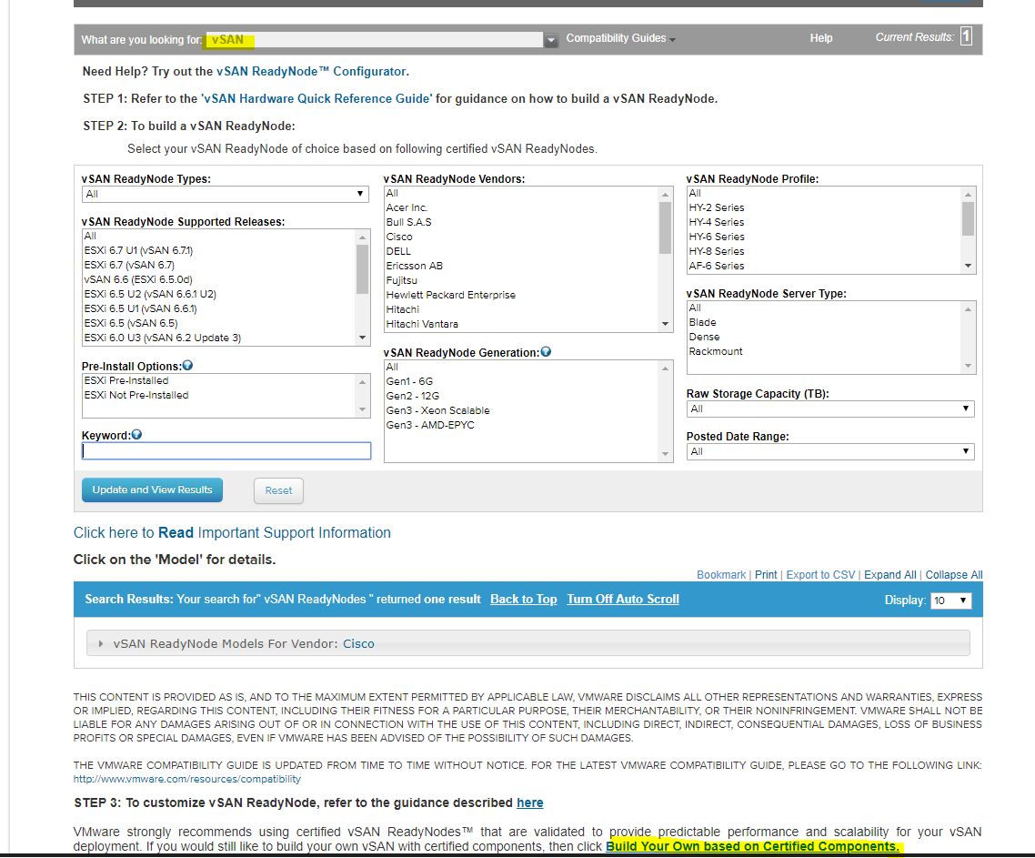

Now put in keywords Controller model is UCSC-SAS-M5HD

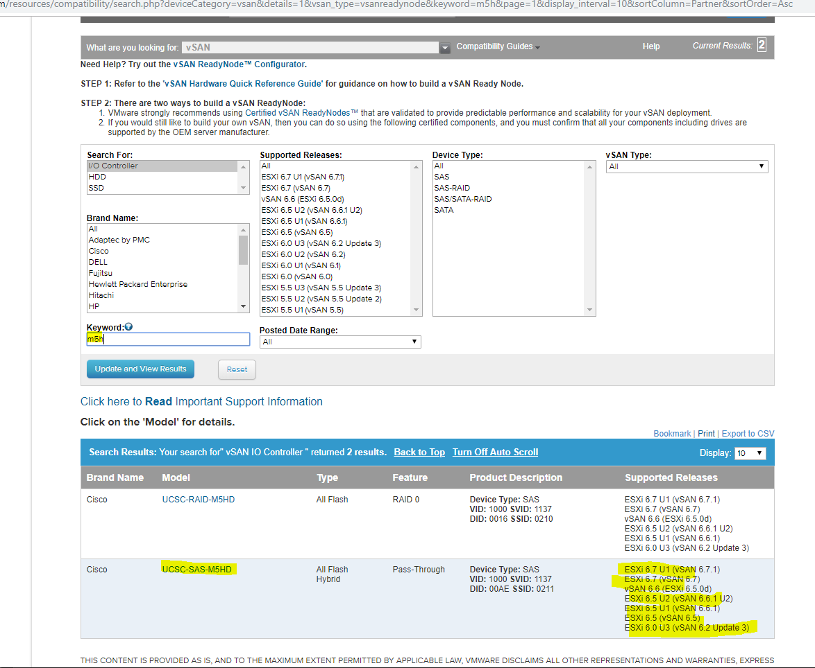

Now we have it.

Click on the controller Model to see it's firmware and drivers requirement.

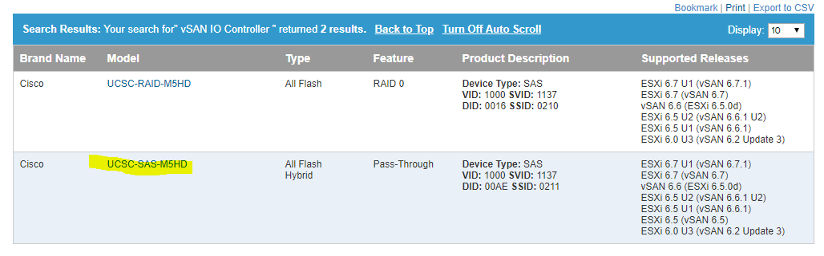

If your ESXi version is running with 6.5U2 than your UCSM should be more than 3.2(1) version

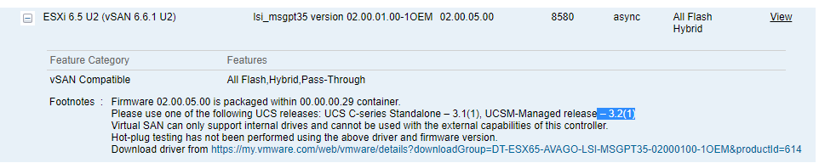

Cisco device driver compatability with your esxi fnic and neenic device driver versions:

<https://ucshcltool.cloudapps.cisco.com/public/>

fc storage

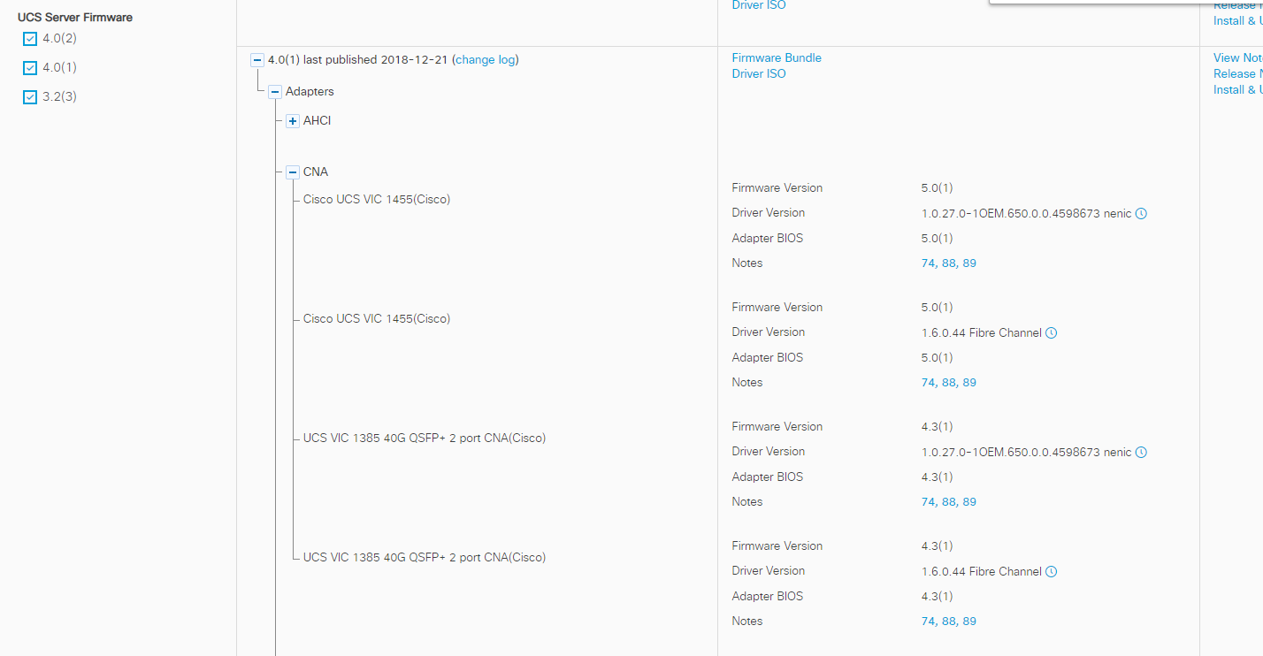

San storage:

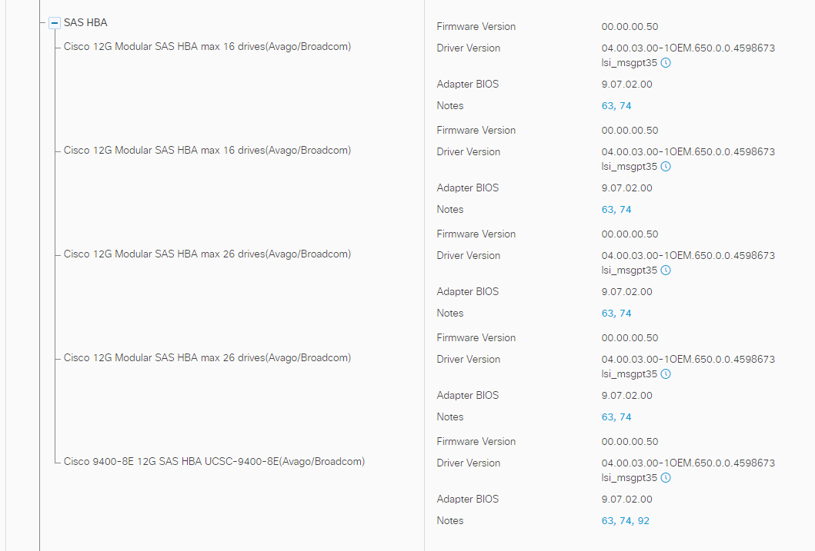

Detailed document to compare and install driver:

<https://www.cisco.com/c/en/us/support/docs/servers-unified-computing/ucs-manager/116349-technote-product-00.html>

